https://www.telegram.com/news/20191213/ri-man-fights-for-right-to-collect-seaweed-on-beach-near-homes

RI man fights for right to collect seaweed on beach near homes
By Brian Amaral/ The Providence Journal Posted Dec 13, 2019 at 2:58 PM
Updated Dec 13, 2019 at 2:58 PM
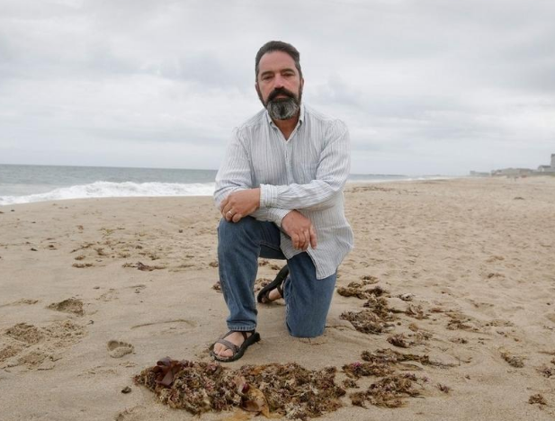

A shoreline rights advocate arrested in June while collecting seaweed on the beach in front of private homes in South Kingstown has settled his federal lawsuit against the town and the police department.
Scott Keeley, of Charlestown, will receive $25,000 in the settlement, according to the town. He said he will use the money to fund the continuing fight to increase shoreline access, including more litigation. “It’s your shoreline,” Keeley said. “If you’re in Rhode Island, it’s your shoreline. And your shoreline is not private.”
Town manager Robert Zarnetske said the Rhode Island Interlocal Risk Management Trust, an insurance pool for local governments in the state, made the “business decision” to settle the case. The town itself was not involved in the decision, which Zarnetske learned about this week. The trust, whose proceeds come from public money, will pay the $25,000, Zarnetske said. “This settlement is the end of a chapter, but by no means resolves the unanswered questions around the balance between private property rights and public access to the shoreline,” Zarnetske said. He added: “The town of South Kingstown will continue to encourage residents and beachgoers to be reasonable and respectful of each other’s interests.”
Brian Cunha, Keeley’s attorney, said the next step will be suing private landowners who are preventing access to the beach. Cunha said he is pleased that the first wave of litigation has been settled. “There’s no question that he shouldn’t have been arrested,” Cunha said. “And the town did the right thing by resolving the case.”
Keeley’s arrest in June highlighted the tension between private property rights and public access in Rhode Island, and the confusion about the boundary between the two.
Public access to the shore is guaranteed in the state Constitution, which says that people will continue to have the right to do things like fish, leave the shore to swim, and even “the gathering of seaweed,” which has been known for generations as an effective fertilizer.
Massachusetts permits limited public access to the beach — mainly for fishing, fowling and navigation.
Rhode Island’s boundary lines are muddled at best.
Keeley went out on June 9 and tested them in what turned out to be a dramatic way, or at least dramatic by the standards of the pleasant coastline on a warm summery day. With a backpack slung over his shoulders to collect the hunks of seaweed, Keeley walked over the line from Charlestown Town Beach to the beach that’s in front of a stretch of private homes just over the line in South Kingstown.
But first he encountered a security guard. Private homeowners in the area had hired him to keep people from settling down on the sand there.
Some private homeowners in the area contend that they own the entirety of the beach in front of their homes — every grain of sand down to the water and even several feet into the water at all times, no matter where the tide is.
Keeley and others say that’s impossible, both constitutionally and geologically. Keeley stuffed seaweed into his bag, sitting down at one point to shake the sand out.
The security guard summoned a police officer, who arrested Keeley on a willful trespassing charge. It was all caught on video, including the officer’s demand that Keeley stop collecting seaweed. The police quickly dropped the trespassing charge, and acknowledged that it’s hard to tell where the line between private property and public access. The department changed its procedures in the wake of the arrest.
At issue in this whole dispute is the mean high tide line, the line that the state Supreme Court says marks the line between private property and public access in the constitution.
In a time of beach erosion and rising sea levels, the line is harder to gauge than it might seem at first blush. Instead of a spot of wet sand, or an area below the seaweed, it’s an average of high tides measured over 18.6-year cycles.
Keeley says that line shouldn’t be used at all to determine the public’s rights; instead the ordinary definition of “shoreline” should govern here, he argues.
In his federal civil suit against South Kingstown, Keeley said his arrest was a violation of his constitutional rights — not just his rights to collect seaweed in the state’s Constitution, but the right to due process in the nation’s.
The suit was buoyed by the fact that even the police acknowledged that he was polite in the midst of his arrest, he said.
The settlement sends a clear message about what people can and should do along the water in Rhode Island, Keeley said. “Don’t be rude. Don’t be a jerk. Don’t think you can go on the dunes or their porch,” he said. “Be reasonably close to the water. And peacefully enjoy your rights.”
If they’re worried, he said, they should bring a fishing pole — fishing from the shore is protected in the state Constitution. Keeley said he is planning to run next year for the Charlestown Town Council, which has shoreline rights issues of its own. The town owns property along the water that isn’t clearly identified as public, Keeley said. “We can have a town that is basically a country club of beach cottage owners,” Keeley said, “or we can have a town where people live and raise their children, who go to school, and graduate and run businesses and have lives.

